**Problem Statement :** Write down the code for Bubble Sort Algorithm in Python.

**Objective :** To Implement the Bubble Sort Algorithm Using Python

**Source Code :**

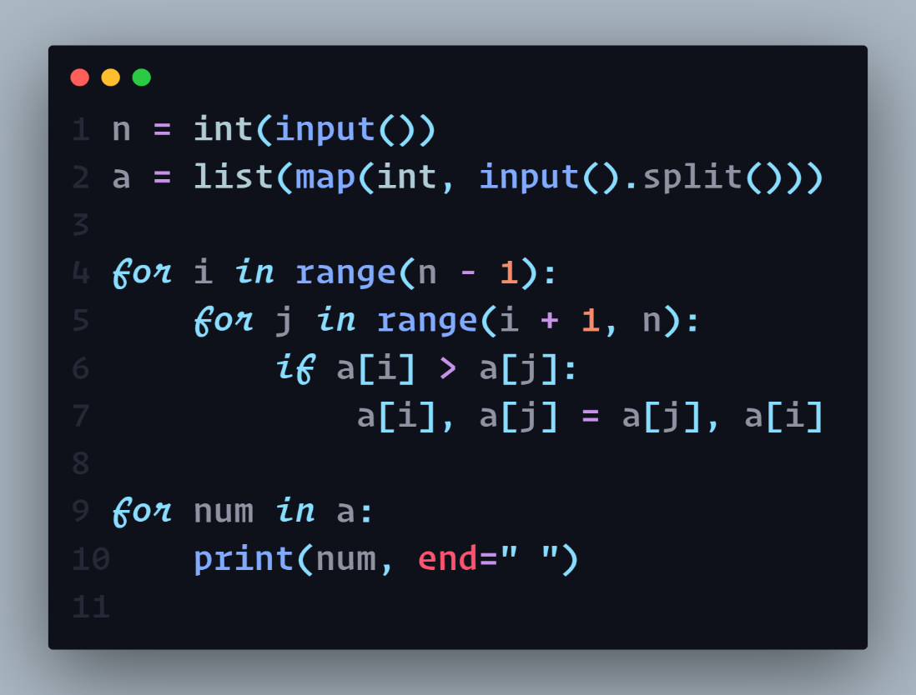

**Input & Output :**

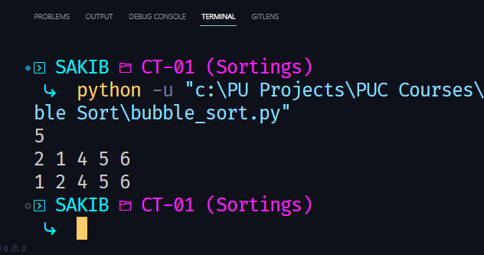

**Problem Statement :** Write down the code for Selection Sort Algorithm in Python.

**Objective :** To Implement the Selection Sort Algorithm Using Python

**Source Code :**

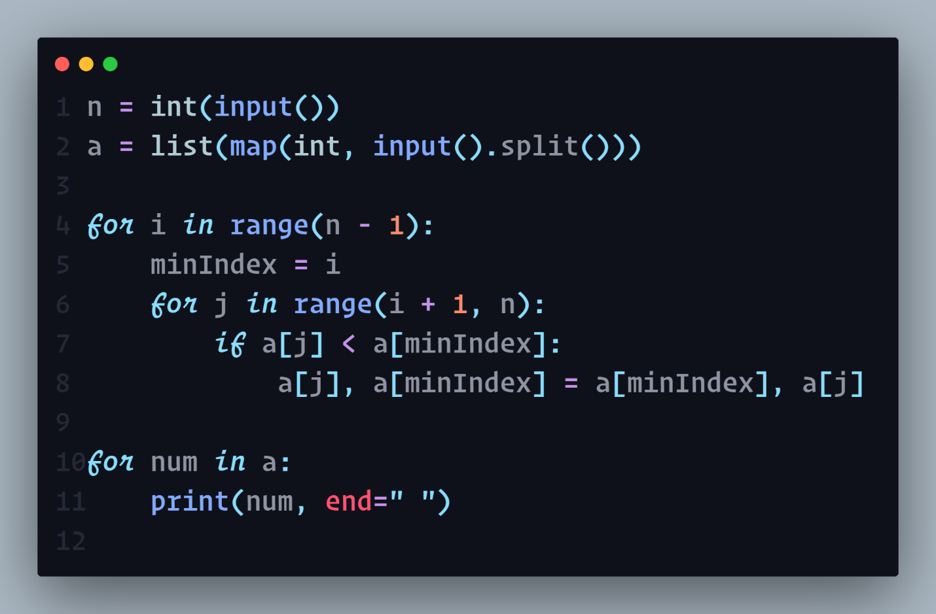

**Input & Output :**

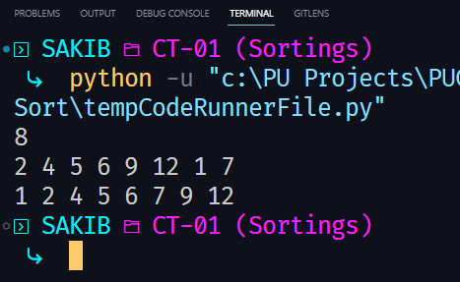

**Problem Statement :** Write down the code for Insertion Sort Algorithm in Python.

**Objective :** To Implement the Insertion Sort Algorithm Using Python

**Source Code :**

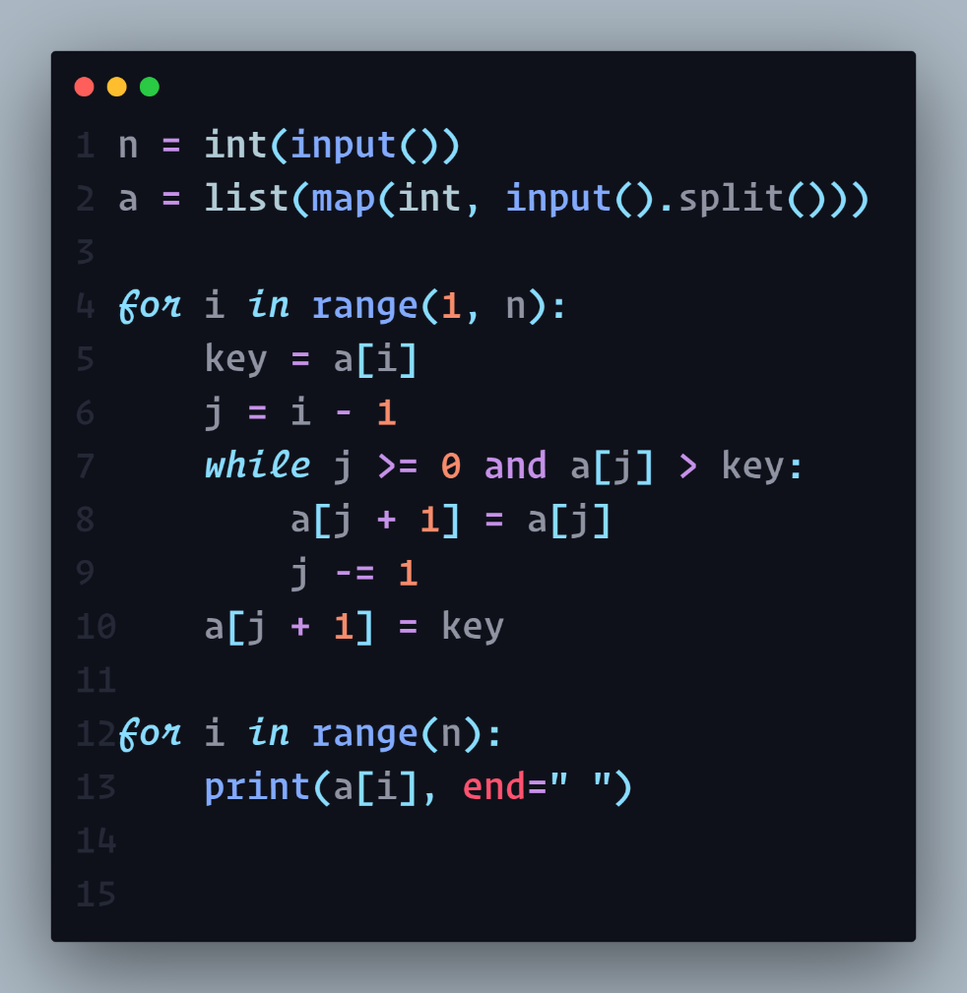

**Input & Output :**

